Final Project Design Phase
Computer Science - Week 11
Oct 3, 2026 - Version 0.0.4

For complete instructions and project ideas, refer to the assignment in Canvas. Specifically, review the final project requirements before you continue below. If you have not reviewed the project requirements in Canvas (you might have to go to the modules view and check the current or past week's content), you will not be able to properly complete the parts below. In addition, it may be helpful to review the information on this Drafter documentation page.

0) Project Planning and Preparation
Successful programmers spend time planning before they begin coding. After reviewing the project requirements, answer the following questions to help guide your design and development process.
- What concepts from class or previous assignments might help you complete this project? Which programming concepts (loops, conditionals, lists, classes, etc.) do you expect to use? What programming skills do you want to improve while completing this project?
The concept of doc stringing functions will definitely help me during this assignment because of the program being so long. The program will have many functions and classes that I will need to use the doc-strings to help keep track of all the moving parts. The programming concepts I expect to use for this project are functions, dataclasses, conditionals, loops, lists, recursion, and drafter. I want to improve my debugging strategies so I can better identify when and where my code needs fixing.

- Which parts of the project do you expect to be the easiest for you? The hardest? Why?
I expect the easiest part of the project to be coming up with functions that get the user input for the game. I expect this because coding these functions generally do not take that long and they usually directly return the input that it receives. I expect the hardest part of this project to be implementing Drafter into the program. I expect this because I am still somewhat shaky with the drafter syntax and I need strong visuals to correctly portray everything that is happening within the game.

- Even though you have not yet designed the final project, estimate which tasks will likely require the most time and effort? Which features or components should be implemented first?
The tasks of keeping track of the game log will take a lot of effort. I will have to come up with an efficient way to remember the history of the game, such as runs, hits, player stamina, and player substitutions left. The feature that I will implement first is creating the teams and randomizing their statistics based on random number generators determined by the difficulty in which the user wants to play at. For example, level 1 difficulty will generate teams with better stats, allowing for more runs to be scored. Level 3 difficulty will generate teams with worse stats, resulting in less runs being scored.

- What distractions might interfere with your work and how will you minimize them? What resources will you need available while working? What questions, if any, do you still have about the assignment requirements?
Distractions that would interfere with my work include work for other classes and studying for finals. I will minimize them by making sure I manage my time wisely and making time for this project alone. I will need a quiet space to work on this so I can lock-in and focus on my coding.

1) Site Diagram
Create a mock-up of your planned website. We suggest you make the mockup on paper, although you can also use software like PowerPoint or Slides to make a mockup. There is other design software that could also be used, but we strongly encourage you to keep it simple. Do not spend more than 15-30 minutes detailing the mock-up. Your goal should be to make a very quick and dirty diagram, to show that you have some kind of idea.

We recommend drawing each page as a rectangle, and laying out the text, buttons, and other components inside. Then, use arrows to indicate links between pages. Label each page the way you will name each function, and then put labels on the arrows to indicate what the button links. Also write down any parameters that should come into the pages.

In addition to the pages and routes, write down what fields your `State` will have, both their names and types. Think clearly about what data will need to be persistent across the entire website.

Add photo(s) or screenshot(s) of your website mock-up and labeled diagram on the next page.
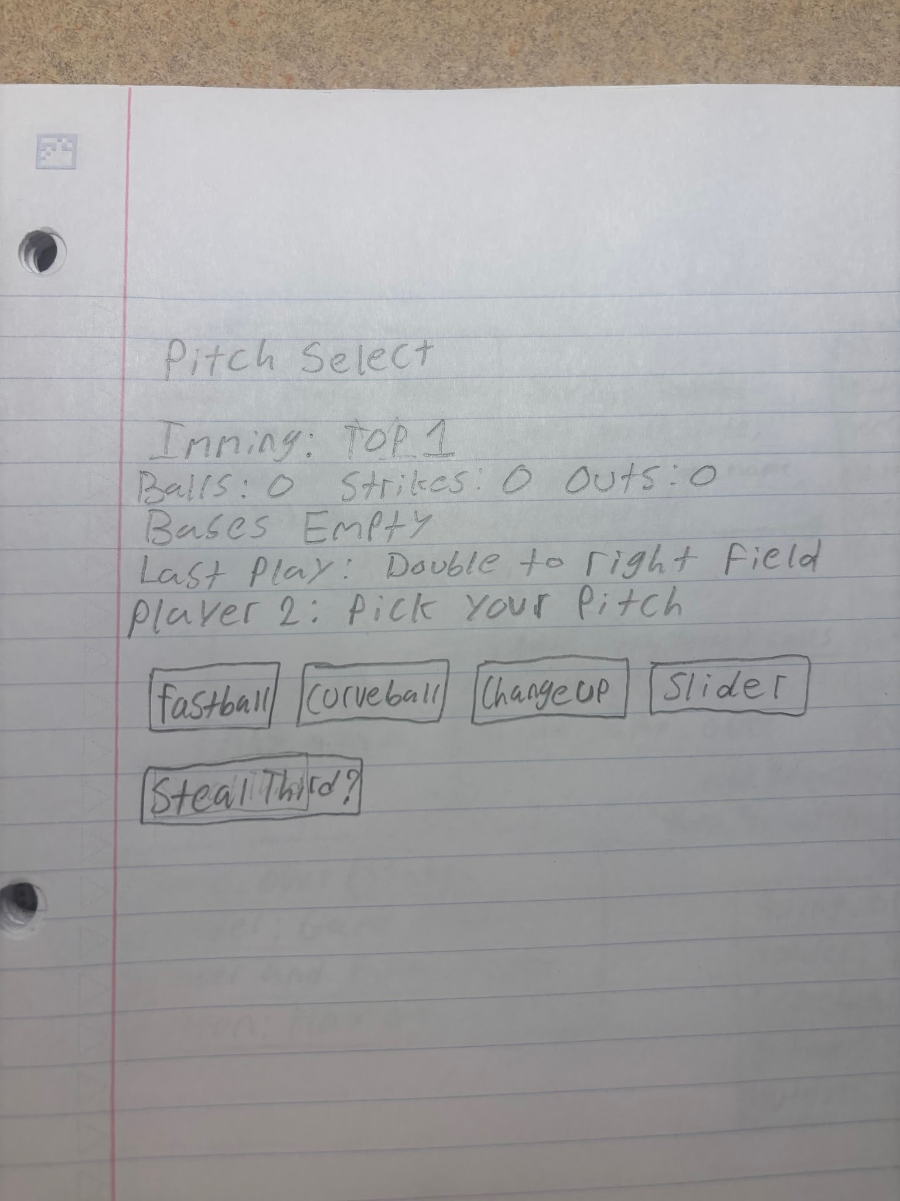
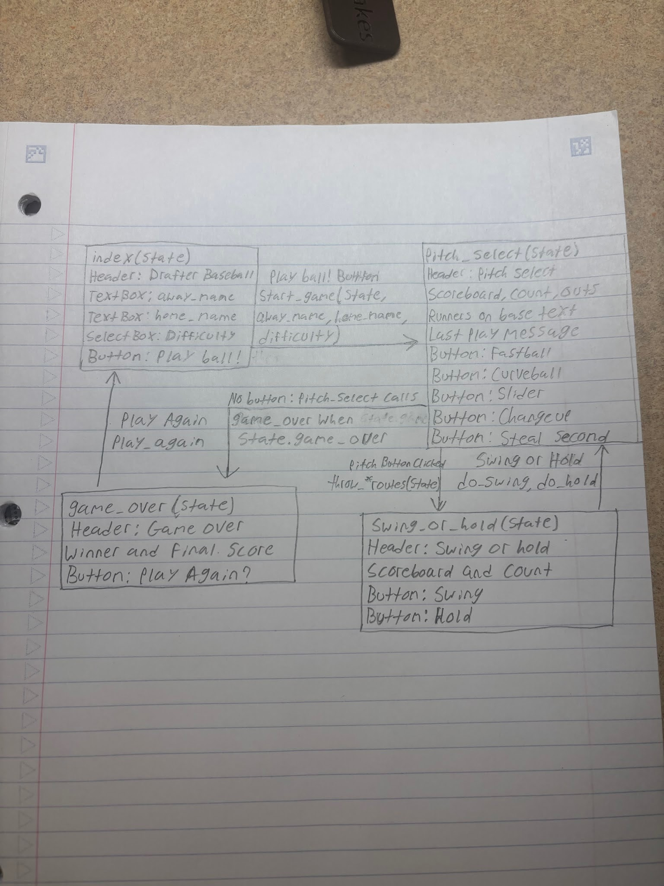
2) Implementing Requirements
This table should serve as a draft for how you will implement the requirements into your final project. You may change your ideas later on, but your final site must fulfill all the requirements.

Requirement | Implementation
Purpose/Functionality  A 1-2 sentence description of the purpose or functionality of your site | The purpose of my site is to supply entertainment to two people by allowing them to play a competitive baseball game against each other which will determine a winner. It will function by using multiple functions and dataclasses to organize the data and execute the gameplay so a winner can be determined fair and square.
State Dataclass Attributes  Minimum of 4 attributes, one of which must be a list/dict of instances of your second dataclass.  Briefly describe each attribute, its type, and how it will be meaningfully modified throughout the site. | @dataclass  class Hitter:  position: str *string with initials of position  number: int *int of player jersey number (1-99)  contact: int *int of contact rating (1-99)  power: int *int of power rating (1-99)  fielding: int *int of fielding rating (1-99)  speed: int *int of speed rating (1-99)  @dataclass  class Pitcher:  velocity: int *int of pitch velocity rating (1-99)  control: int *int of pitch control rating (1-99)  movement: int *int of pitch movement rating (1-99)  stamina: int *int of pitcher stamina rating (1-99)  fielding: int *int of fielding rating (1-99)  Note: The list and dicts of these dataclasses are in my second dataclass in the box below
Second Dataclass  Your second dataclass, including its attributes, their types, and how they will be meaningfully modified (if they are modified) | @dataclass  class Team:  pitchers: list[Pitcher] *list of pitchers that are available to play in the game (starters and bullpen arms)  catcher: Hitter *starting catcher in the game  first_base: Hitter *starting first basemen in the game  second_base: Hitter *starting second basemen in the game  thrid_base: Hitter *starting third basemen in the game  short_stop: Hitter *starting shortstop in the game  left_field: Hitter *starting left fielder in the game  center_field: Hitter *starting center fielder in the game  right_field: Hitter *starting right fielder in the game  The pitchers instance in the Team dataclass will change because after a pitcher is taken out of the game, they will be removed from the list of pitchers, removing them from having the option to be put back into the game.
Routes (minimum 7)  The names of your route functions | - index  - lineup_setup  - pitch_select  - swing_or_hold  - baserunning_choice  - substitutions  - game_over
Pages (minimum 5)  A brief description of the pages in your site | Title/Setup (index): This will be the welcome screen where players can enter their name and game difficulty. They can also start the game from here  Pitch Select (pitch_select): The team on defense will select the next pitch type they would like to throw. This page will also showcase the outs, count, and inning  Swing or Hold (swing_or_hold): The team on offense will select whether or not they want to swing at the incoming pitch or not. If they do swing, the program will go through the stats and generate the outcome of the swing.  Baserunning Choice (baserunning_choice): Appears when runners are on base and gives the user the option to steal or not. Also, after a ball is put in play, the user on offense can select whether or not they want to advance the runner.  Game Over (game_over): This will be the final screen. It will display the winner, loser, final score, and box score of the game. The users can choose to play again from this screen as well.
User Input (minimum 3)  Description of user input components (TextBox, TextArea, CheckBox, or SelectBox) and their purposes  For more information on these input types, see Drafter Documentation. | Buttons for pitch_select and swing_or_hold: Each button will be linked to a route function which directly inputs the decision based on what the user clicks.  TextBox for difficulty selection: The user will input text stating what they want to choose for the options suggested. Such options include difficulty levels at the beginning of the game.  SelectBox for Pitching Changes: The user will have a dropdown menu present with all of the options for relief pitchers. The user can choose the relief pitcher of their choice when necessary.
If Statements (minimum 3)  Brief description of what will be evaluated in your if statements and how they will meaningfully change the logic of the site | 3 Outs Ends the Half Inning: This if statement will move the game to the next half inning while clearing the bases, outs, balls, and strikes.  Only Offer the Option to Steal a Base When You Can: This if statement will present the user with the option to steal a base when there are runners on base. If no runners are on base, then the option will not be present via the if statement.  Game is Over After the Last Half Inning: This if statement will check if the games are over by seeing if the 9th inning is over. If the home team is up, the game will end after the top of the inning. If the home team is loosing, the game will go into the bottom
Loop (minimum 1)  This loop must iterate over the list/dict of dataclass instances in your State attribute.  Description of this loop and why it is meaningful to the site | Pitching Options Loop: There will be a for loop which iterates over the list of pitchers in the Team dataclass. Each time a pitching change happens, the function with the loop will be called which generates a new selection of pitchers, removing the pitcher that was already put into the game. This is meaningful because it prevents the same pitcher from being used in the game twice, which is not allowed in real-life baseball.

LLM Conversation
If you used an LLM in any part of this work, copy and paste every part of that conversation below. Otherwise, you may be given a zero for the assignment. Obviously, these words will not all be yours, and this is the exception to the requirement at the top of this assignment that all responses be in your own words. If you did not use an LLM to assist you in this assignment, simply say so below.

Claude
I am making a 2-player baseball game in python. How will the computer manipulate or evaluate these user inputs at a high level? (Game difficulty, swing or hold, pitch selection, steal or no steal, send the runner or hold the runner on a hit, pitching change, pinch hitter, pinch runner.)
The core idea: player inputs never decide outcomes directly. They shift probabilities, and the computer rolls dice against those probabilities. Each input either (a) changes the odds of an event or (b) changes the game state (who’s on the field, who’s on base).

The pitch/swing core
Treat each pitch as one resolution step: pitcher’s choice and batter’s choice go in, one outcome comes out.
- Pitch selection sets the pitch’s attributes: base chance of being a strike, how hard it is to hit, how likely it produces weak contact or a strikeout. A fastball might be high-strike and high-contact-risk, while a curve or changeup is harder to hit but more likely to miss the zone. The pitcher’s ratings and fatigue modify these numbers.
- Swing or hold is then evaluated against the pitch:
  - Hold: roll for ball vs. called strike, based on the pitch’s strike probability.
  - Swing: roll for whiff vs. contact. If contact, roll again on contact quality (weak, solid, hard), which maps to foul, out, single, double, triple, or homer, weighted by the batter’s ratings.
- Matchup is the optional spice: if the batter “guesses” or the pitch type is a good or bad fit for that batter, nudge the odds. You can keep it simple at first and skip this.
A common structure is a function like resolve_pitch(pitch, swing, pitcher, batter, difficulty) that returns an outcome string, which a separate state-update function then applies to balls, strikes, outs, and runners.

Difficulty
Since it’s 2-player, difficulty doesn’t control an AI opponent. It controls how forgiving the dice are. Options:
- Scale the probability tables (e.g., difficulty “hard” lowers contact chance and raises strikeout chance for everyone).
- Scale the penalty for mistakes (steal-caught odds, fatigue rate, error rate).
- Optionally, let the two players pick different difficulties as a handicap (it just changes each side’s modifiers).
Keep it as one multiplier or a small lookup table, applied inside the probability calculations, so it doesn’t leak all over your code.

Baserunning inputs
- Steal or no steal: only valid when a runner is on and the next base is open. Success probability = f(runner speed, pitcher’s hold/time-to-plate, catcher arm, pitch type, e.g. a curve is slower to the plate). Roll once: safe, or caught (an out, runner removed). Resolve it before or alongside the pitch, depending on how you want the pitch to count (a common simplification: steal resolves, then the pitch is still thrown, or the pitch is a “no pitch” if the runner is out).
- Send or hold the runner on a hit: this is a risk decision made after the hit is determined. The computer knows the hit type, which gives a “standard” advancement (single: runner from second goes to third or scores, etc.). Sending the runner takes the extra base at some probability that depends on runner speed, hit depth/strength, outfielder arm, and number of outs. Holding takes the safe base with certainty. Roll for safe/out on the send.

Substitutions
These aren’t probability events. They’re state changes with validation:
- Pitching change: swap the active pitcher with someone from the bullpen. Validate that the replacement is available and hasn’t already been used. The new pitcher comes with his own ratings and fresh fatigue, and the old pitcher can’t return. Fatigue can be a counter (pitches thrown) that degrades the pitcher’s ratings past a threshold, so the choice to change has real stakes.
- Pinch hitter: replace the scheduled batter for this plate appearance with a bench player. The replacement takes that spot in the lineup (and usually the field position afterward, so you may need a defensive-position rule). Bench players are spent once used.
- Pinch runner: replace a base runner with a bench player, who takes that lineup spot. Typically a faster, weaker hitter, so the tradeoff is speed now versus bat later.
In code, all three are the same shape: check legality, mutate the lineup/roster data structure, and update which player object the probability functions read from.

How it fits together
Think of the game as a loop around a game state object (inning, outs, count, runners, score, lineups, bench, bullpen, pitch counts). Each turn:
- Collect and validate inputs (only offer legal choices, like a steal only when a runner is on).
- Convert inputs plus player ratings plus difficulty into probabilities.
- Roll random numbers to pick the outcome.
- Apply the outcome to the game state and check for end of at-bat, half-inning, or game.
Designing it this way means each input is just one more modifier or one more state mutation, so you can add features (new pitch types, injuries, weather) later without rewriting the core.
If you’d like, I can sketch the probability tables or the game-state class next. Which piece do you want to build first?
What details would I need to ignore in my program?
Deciding which baseball details a program can leave out.
You can skip a lot. The rule of thumb is to keep anything that creates a decision for a player, and drop anything that only adds bookkeeping. Here’s what most simple baseball games safely ignore.
Fielding and defense
- Individual fielder positions, ranges, and arm strength (use one team-wide defense rating instead, if you want defense at all).
- Errors as a separate system. You can fold them into the outcome table as a small chance that an out becomes a safe runner.
- Defensive shifts, outfield depth, infield-in, and cutoff throws.
- Defensive positions for substitutes. Let any bench player play anywhere.
Pitch-level detail
- Pitch location and the strike zone map. “Strike probability” as a single number is enough.
- Pitch velocity, spin, and movement. Pitch types can just be labels with a few stats each.
- Catcher framing, umpire tendencies, and balks.
- Foul-ball subtleties like fouling off two-strike pitches versus foul tips. Treat a foul as “strike unless already two strikes.”
Hitting and contact
- Exact hit location, exit velocity, and launch angle. A contact-quality roll mapped to an outcome covers it.
- Ground-rule doubles, bad hops, and ballpark effects.
- Platoon splits (lefty vs. righty), though this is a nice optional upgrade later.
Baserunning
- Leads, pickoff attempts, and runners tagging up on fly balls (or make sac flies automatic when conditions fit).
- Runner-on-runner interactions, like two runners trying to occupy the same base or double-play pivot mechanics. A simple “ground ball with runner on first and fewer than two outs has X% chance of a double play” is enough.
- Rundowns, which you can resolve with a single roll.
- Passed balls, wild pitches, and runners advancing on them.
Rules and situations
- Infield fly rule, interference, obstruction, and dropped third strike.
- Ejections, injuries, and weather delays.
- Extra-inning rules (a runner starting on second), unless you want them. You can just keep playing until someone leads after a full inning.
- Roster minimums, designated hitter debates, and the three-batter minimum for relievers. Pick one DH rule or none.
Player and season detail
- Detailed stat tracking (batting average, ERA, etc.), unless you want a box score. You can bolt it on later without touching the core logic.
- Aging, morale, streaks, and contracts.
- Real-player ratings. Made-up or randomly generated ratings are fine.
A few things to keep even in a minimal version
- Balls, strikes, outs, and the count rules.
- Force plays versus non-force plays at least in basic form, since they affect who can advance on a ground ball.
- Fatigue or pitch count, because without it the pitching change decision has no reason to exist.
- Bench players being a one-time resource, because that gives pinch hitters and runners a real cost.
A good strategy is to build the simplified version first with everything above ignored, get one full 9-inning game working, and then add back whichever details you miss most, one at a time. If you design your outcome functions to take a few modifiers, most of these can be added later without a rewrite.
Here are three Drafter input components that fit your game well.
1. Button
This is your main decision input. Each button links to a route function, so clicking it is the decision. On pitch_select you’d have one button per pitch type, and on swing_or_hold you’d have a Swing button and a Hold button. Each target route can record the choice in the state and run the roll.
python

Button("Swing", swing_result)
Button("Hold", hold_result)
2. TextBox
This collects typed text. You’d use it on the title screen for each player’s name, so the scoreboard and prompts can say “Player 1’s turn” with real names.
python

TextBox("player1_name", state.player1_name)
3. SelectBox
This is a dropdown for picking one option from a list. It works well for game difficulty on the title screen, and for choosing which bench player to bring in on the substitutions page (pinch hitter, pinch runner, or new pitcher).
python

SelectBox("difficulty", ["Easy", "Medium", "Hard"], state.difficulty)
When a button is clicked, Drafter passes the current values of the text boxes and select boxes to the target route function as arguments, matched by the names you gave them. So a start_game(state, player1_name, difficulty) route would receive what the players entered.
A CheckBox is another option if you want a simple on/off setting, like turning the pitch-count display on or off. Check the Drafter documentation for the exact current signatures, since details can vary between versions.
Here are three if statements your game will need, each guarding a different part of the flow.
1. Three outs ends the half-inning
python

if state.outs >= 3:
state.outs = 0
state.balls = 0
state.strikes = 0
state.bases = [False, False, False]
if state.top_of_inning:
state.top_of_inning = False
else:
state.top_of_inning = True
state.inning += 1
This clears the outs, count, and runners, then switches sides, and only advances the inning number after the bottom half.
2. Only offer a steal when it’s legal
python

if state.bases[0] and not state.bases[1] and state.outs < 3:
buttons.append(Button("Steal second", steal_second))
This shows the steal button only when there’s a runner on first, second base is open, and the half-inning isn’t over. You can write similar checks for stealing third, pinch runner (a runner exists and a bench player is available), and pitching change (the bullpen isn’t empty).
3. The game is over after the final inning
python

if state.inning > 9 and state.top_of_inning and state.home_score != state.away_score:
return game_over(state)
This checks that the ninth inning has finished (we’ve moved to the top of the 10th) and that the score isn’t tied, then sends the players to the game_over page. Because it requires a non-tied score, a tie keeps the game going into extra innings. One more rule you’ll want is ending the game early when the home team takes the lead in the bottom of the ninth or later.
Come up with a loop that will iterate over the Team dataclass which has an instance named pitcher which is a list[Pitcher]
Since pitcher is a list on your Team dataclass, you loop over team.pitcher rather than over the team itself.
python

for pitcher in team.pitcher:
print(pitcher.name)
A more useful version for your game builds the pitching change options on the substitutions page, skipping the pitcher who’s currently in the game and anyone already used:
python

@route
def substitutions(state: State) -> Page:
team = state.fielding_team
page = ["Choose a new pitcher:"]
for pitcher in team.pitcher:
if pitcher is not state.current_pitcher and not pitcher.used:
page.append(Button(pitcher.name, make_pitching_change))
return Page(state, page)
A few notes:
- Index loop: If you also need the position in the list, use for i, pitcher in enumerate(team.pitcher):.
- Finding one pitcher: To grab the best available arm instead of listing them all, loop and track the best one, or use max(candidates, key=lambda p: p.rating) on a filtered list.
- Button targets: In Drafter, each button calls a route function, so make_pitching_change won’t know which pitcher was clicked. Two common fixes are to put the choices in a SelectBox (the chosen name gets passed to your route as an argument) or to create a small route per choice. The SelectBox is usually simpler.
I can show the SelectBox version with the matching make_pitching_change(state, new_pitcher_name) route if you’d like.
Claude works directly with your codebase
Claude is AI and can make mistakes. Please double-check responses.
Claude finished the response

Final Submission
When you are finished, download this file as a Word Document (docx) and upload the file to the appropriate assignment on Canvas.

